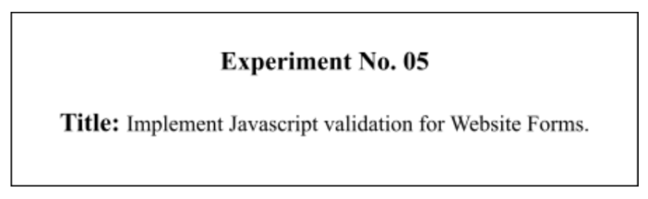

# Batch: B-4 Roll No.: 16010422234 Name: Chandana Ramesh Galgali

# Experiment No.:5

**Aim**: To Implement Javascript validation for Website Forms.

**_____________________________________________________________________________**

# Resources needed: Notepad++, Web Browser

**_____________________________________________________________________________**

# Theory:

JavaScript is a scripting language produced by Netscape for use within HTML Web pages. JavaScript is loosely based on Java and it is built into all the major modern browsers.

JavaScript is a lightweight, interpreted programming language, complementary to and integrated with Java, complementary to and integrated with HTML , open and cross-platform and is case sensitive.

Data validation is the process of ensuring that user input is clean, correct, and useful. Typical validation tasks are:

* Has the user filled in all required fields?
* Has the user entered a valid date?
* Has the user entered text in a numeric field?
* Most often, the purpose of data validation is to ensure correct user input.

Validation can be defined by many different methods, and deployed in many different ways.

* Server side validation is performed by a web server, after input has been sent to the server.
* Client side validation is performed by a web browser, before input is sent to a web server.

For example HTML form validation can be done by JavaScript. If a form field (fname) is empty, this function alerts a message, and returns false, to prevent the form from being submitted:

function validateForm() {

var x = document.forms["myForm"]["fname"].value; if (x == "") {

alert("Name must be filled out"); return false;

}

}

**_____________________________________________________________________________**

# Activity:

Add validations for the Website Forms Such as

1. Name should string
2. Roll number should a number
3. Email id should have @ and . in it
4. Telephone number should be a ten digit number.

# Students need to add various validations to their form input as per the requirement of the user interface.

**_____________________________________________________________________________**

**Results: (Program printout with output)**

**Code:**

**<!-- HTML FILE -->**

**<!DOCTYPE html>**

**<html lang="en">**

**<head>**

**<meta charset="UTF-8">**

**<meta name="viewport" content="width=device-width, initial-scale=1.0">**

**<title>Student Registration Form</title>**

**<link rel="stylesheet" href="style.css">**

**</head>**

**<body>**

**<div class="container">**

**<h1>Student Registration Form</h1>**

**<form id="registrationForm">**

**<label for="name">Name:</label>**

**<input type="text" id="name" required>**

**<label for="rollNumber">Roll Number:</label>**

**<input type="text" id="rollNumber" required>**

**<label for="email">Email ID:</label>**

**<input type="email" id="email" required>**

**<label for="telephone">Telephone Number:</label>**

**<input type="text" id="telephone" required>**

**<label for="address">Address:</label>**

**<textarea id="address" required></textarea>**

**<label for="gender">Gender:</label>**

**<select id="gender" required>**

**<option value="" disabled selected>Select Gender</option>**

**<option value="male">Male</option>**

**<option value="female">Female</option>**

**<option value="other">Other</option>**

**</select>**

**<label for="dob">Date of Birth:</label>**

**<input type="date" id="dob" required><br><br>**

**<label for="course">Course:</label>**

**<select id="course" required>**

**<option value="" disabled selected>Select Course</option>**

**<option value="Computer Science">Computer Science</option>**

**<option value="Information Technology">Information Technology</option>**

**<option value="Electronics and Computer Science">Electronics and Computer Science</option>**

**<option value="Electronics and Telecommunications">Electronics and Telecommunications</option>**

**<option value="Mechanical">Mechanical</option>**

**</select>**

**<button type="submit">Submit</button>**

**</form>**

**</div>**

**<script src="script.js"></script>**

**</body>**

**</html>**

**/* CSS FILE */**

**body {**

**font-family: Arial, sans-serif;**

**margin: 0;**

**padding: 0;**

**background-color: #f2f2f2;**

**}**

**.container {**

**width: 50%;**

**margin: 50px auto;**

**background-color: #aebdca;**

**padding: 30px;**

**border-radius: 10px;**

**box-shadow: 0 0 10px rgba(0, 0, 0, 0.1);**

**}**

**h1 {**

**text-align: center;**

**margin-bottom: 30px;**

**}**

**label {**

**display: block;**

**margin-bottom: 5px;**

**}**

**input[type="text"],**

**input[type="email"],**

**textarea,**

**select {**

**width: calc(100% - 22px);**

**padding: 10px;**

**margin-bottom: 20px;**

**border: 1px solid #ccc;**

**border-radius: 5px;**

**}**

**button {**

**width: 100%;**

**padding: 10px;**

**background-color: #4b4b4b;**

**color: #fff;**

**border: none;**

**border-radius: 5px;**

**cursor: pointer;**

**}**

**button:hover {**

**background-color: #0056b3;**

**}**

**// JS FILE**

**document.getElementById('registrationForm').addEventListener('submit', function(event) {**

**event.preventDefault();**

**var name = document.getElementById('name').value;**

**var rollNumber = document.getElementById('rollNumber').value;**

**var email = document.getElementById('email').value;**

**var telephone = document.getElementById('telephone').value;**

**if (!isNaN(name)) {**

**alert('Name must be a string of alphabets only.');**

**return;**

**}**

**if (isNaN(rollNumber)) {**

**alert('Roll number must be a number.');**

**return;**

**}**

**if (email.indexOf('@') < 0 || email.indexOf('.') < 0) {**

**alert('Email ID must contain an "@" and "."');**

**return;**

**}**

**if (!(/^\d{10}$/.test(telephone))) {**

**alert('Telephone number must be a 10 digit number.');**

**return;**

**}**

**alert('Form submitted successfully!');**

**});**

**Output:**

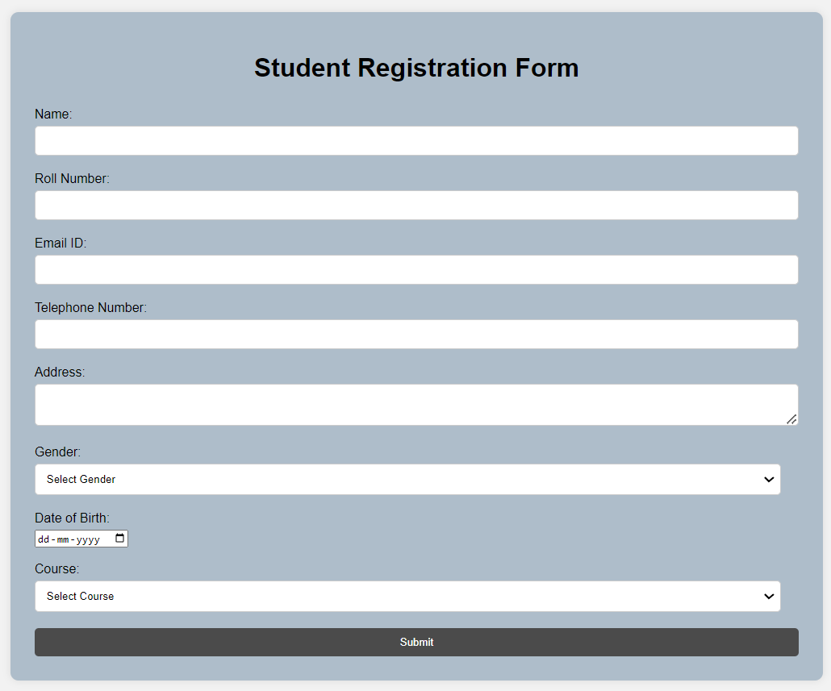

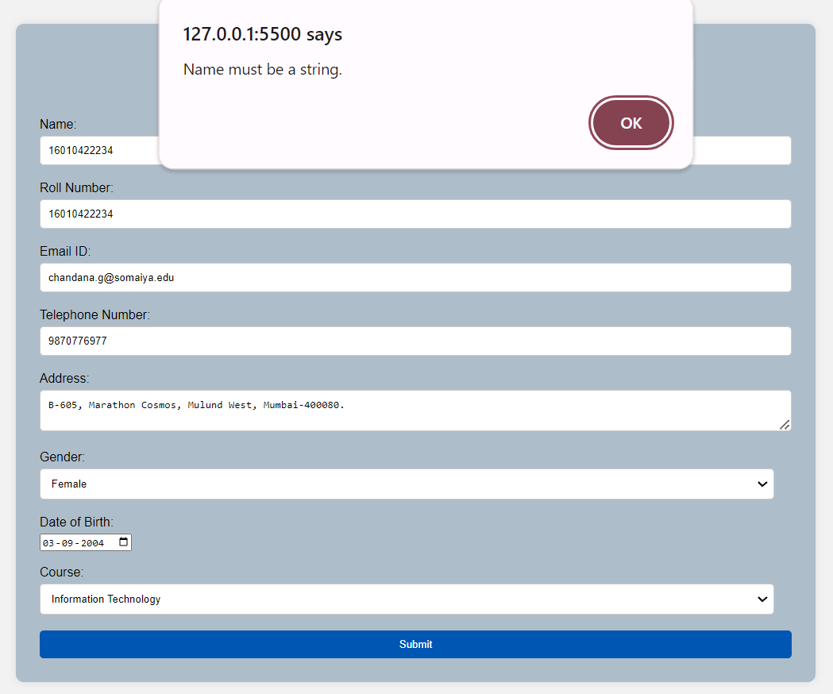

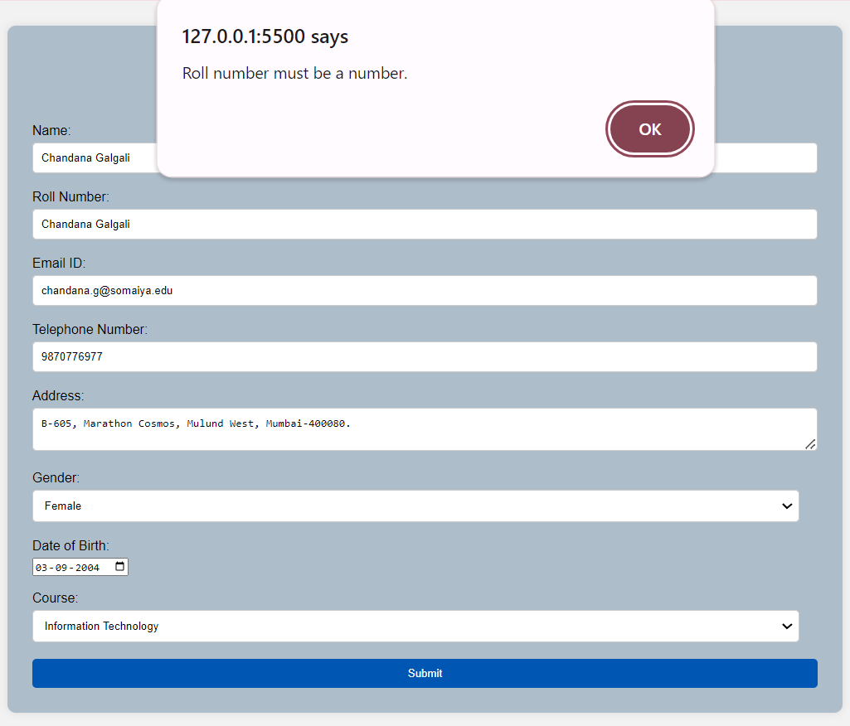

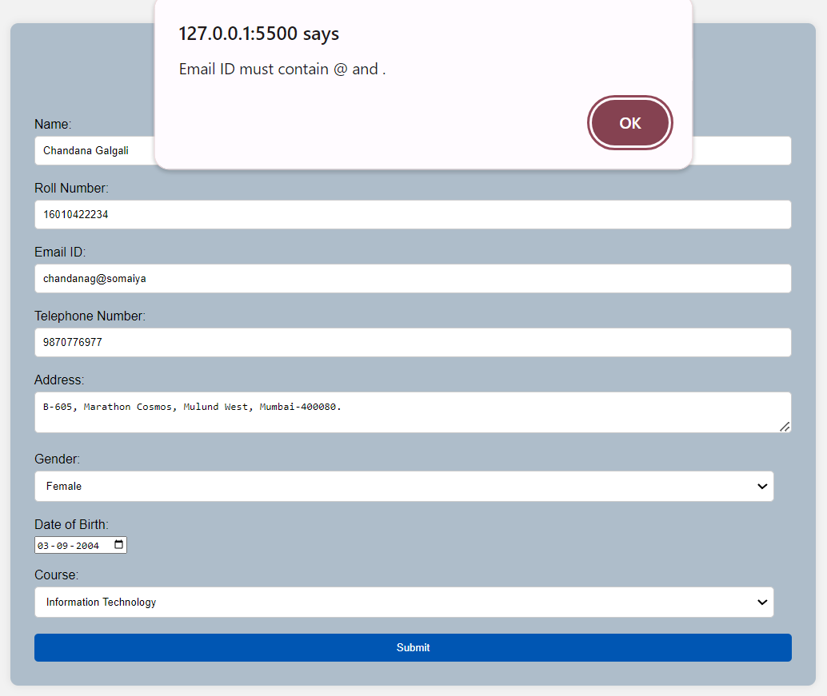

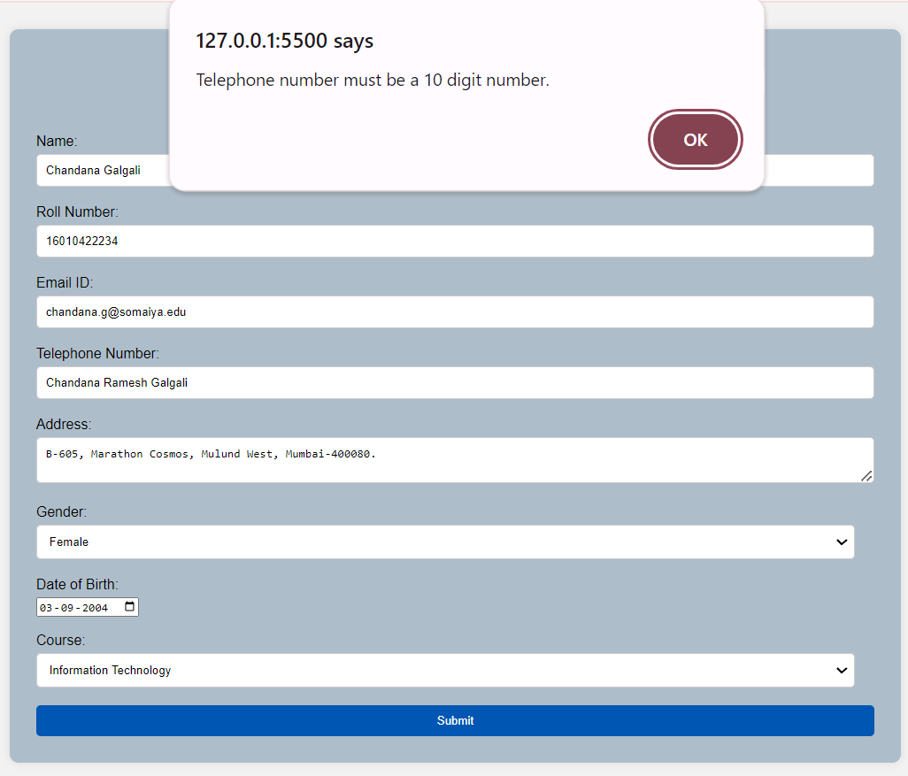

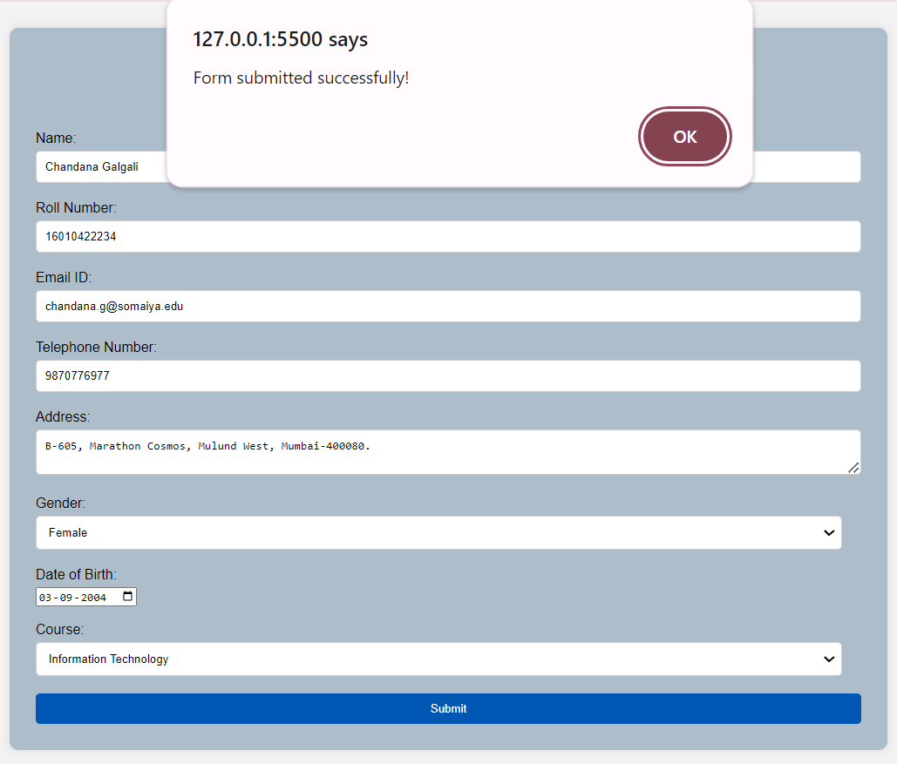

**_____________________________________________________________________________**

# Questions:

**Q1) Why to carry out Validation at client side using scripting language?**

**Ans:** Carrying out validation at the client side using scripting languages like JavaScript is beneficial for several reasons:

* Immediate Feedback: Client-side validation provides immediate feedback to the user without the need for server round trips, enhancing user experience by quickly identifying and correcting errors.
* Reduced Server Load: Since validation is done on the client side, it reduces the load on the server, as the server does not have to process validation requests. This can lead to more efficient and scalable applications.
* Ease of Use: JavaScript, the most widely used client-side scripting language, is relatively easy to learn and use, making it accessible to developers with various levels of expertise.
* Speed: Client-side validation can be faster than server-side validation because the code executes directly in the user's browser without the need to send data back to the server for processing.

**Q2) What is the difference between client side validation and server side validation?**

**Ans:** The difference between client-side validation and server-side validation lies in where the validation takes place and the implications of each approach:

Client-side Validation:

* Location: Validation occurs in the user's browser, using client-side scripting languages like JavaScript 2.
* Benefits: Provides immediate feedback, reduces server load, and is faster since it executes in the user's browser 2.
* Limitations: Not secure, as client-side code can be viewed and manipulated by users. It also depends on the user's browser and settings, and cannot validate data if JavaScript is disabled 2.

Server-side Validation:

* Location: Validation occurs on the server, where the data is processed and checked before it is stored or used 4.
* Benefits: More secure as it cannot be bypassed by users. It is necessary for validating data that comes from untrusted sources or for operations that require complex validation logic 4.
* Limitations: Involves server round trips, which can affect performance and user experience. It is also more resource-intensive on the server side 4.

In summary, while client-side validation enhances user experience and reduces server load, it is less secure and depends on the user's browser. Server-side validation is more secure and can handle complex data validation but requires more resources and affects performance.

**_____________________________________________________________________________**

# Outcomes: Apply JavaScript and JSON for web application development

**_____________________________________________________________________________**

**Conclusion: (Conclusion to be based on the outcomes achieved)**

The experiment successfully demonstrates the value of implementing JavaScript validation for website forms, focusing on improving user experience, reducing server load, and ensuring data integrity through a combination of client-side and server-side validation. The experiment also underscores the importance of adhering to best practices and considering future improvements to enhance the overall effectiveness and security of form handling on websites.

**_____________________________________________________________________________**

# Grade: AA / AB / BB / BC / CC / CD /DD

**Signature of faculty in-charge with date**

**_____________________________________________________________________________**

# References:

**Books/ Journals/ Websites:**

* “Web technologies: Black Book”, Dreamtech Publications
* [http://www.w3schools.com](http://www.w3schools.com/)

**_____________________________________________________________________________**